28. Write a program to find the

a) Average of three integer numbers, three float numbers(should have same method name)

**package** MyFirstPackage;

**import** java.util.Scanner;

**public** **class** CalculateAverage {

**public** **static** **void** main(String[] args) {

// **TODO** Auto-generated method stub

Scanner input = **new** Scanner(System.***in***);

// Calculate the average of three integers

System.***out***.println("Enter three integers:");

**int** int1 = input.nextInt();

**int** int2 = input.nextInt();

**int** int3 = input.nextInt();

**double** intAverage = *calculateAverage*(int1, int2, int3);

System.***out***.println("Average of integers: " + intAverage);

// Calculate the average of three float numbers

System.***out***.println("Enter three floating-point numbers:");

**float** float1 = input.nextFloat();

**float** float2 = input.nextFloat();

**float** float3 = input.nextFloat();

**double** floatAverage = *calculateAverage*(float1, float2, float3);

System.***out***.println("Average of floating-point numbers: " + floatAverage);

}

// Calculate the average of three integers or floats

**public** **static** **double** calculateAverage(**int** num1, **int** num2, **int** num3) {

**return** (num1 + num2 + num3) / 3.0;

}

**public** **static** **double** calculateAverage(**float** num1, **float** num2, **float** num3) {

**return** (num1 + num2 + num3) / 3.0;

}

}

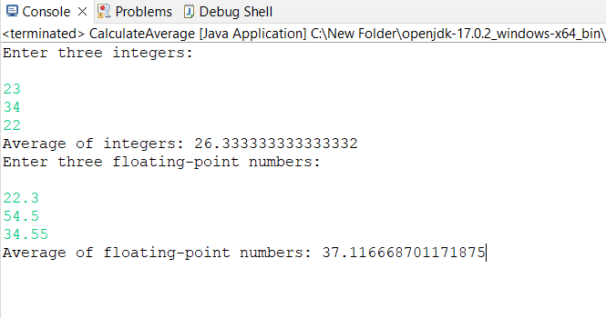

b) Area of figures(circle, rectangle, square) by using three methods(should have same method name)

**package** MyFirstPackage;

**public** **class** CalculateAreaSecond {

**public** **static** **void** main(String[] args) {

// **TODO** Auto-generated method stub

**double** circleRadius = 5.0;

**double** circleArea = *calculateArea*(circleRadius);

System.***out***.println("Area of the circle: " + circleArea);

**double** rectangleLength = 4.0;

**double** rectangleWidth = 6.0;

**double** rectangleArea = *calculateArea*(rectangleLength, rectangleWidth);

System.***out***.println("Area of the rectangle: " + rectangleArea);

**double** squareSide = 7.0;

**double** squareArea = *calculateArea*(squareSide);

System.***out***.println("Area of the square: " + squareArea);

}

**public** **static** **double** calculateArea(**float** radius) {

**return** Math.***PI*** * radius * radius;

}

**public** **static** **double** calculateArea(**double** length, **double** width) {

**return** length * width;

}

**public** **static** **double** calculateArea(**double** side) {

**return** side * side;

}

}

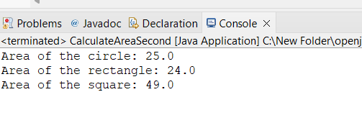

29. Write the above program with parameterized constructor (to calculate total amount). (instance methods)

30. Write a program to find the grade of 2 students based on total marks(3 subjects) • Get the student‟s marks by constructor • Return total mark to in main method • Find the grade of each student.

31. Write a program to find the Area of figures a) Circle (pi*r*r) b) Rectangle(l*b) c) Square(a*a) • Prompt the user to select the options(a/b/c) from command prompt. • Get the inputs that needs to find area.